**Lab Objectives**: In this lab you will gain familiarity with, position, motion (velocity) and changes in motion (accelerations) and their representation as plots of position, velocity and acceleration as functions of time. By making use of the motion sensor you will be able to graph these quantities in real time and explore the calculus of the relations between them.

At the end of this lab should you be able to clearly distinguish between velocity and acceleration, and give examples of how these are distinctly different physical quantities.

You should also be able to explain how objects acquire accelerations, via Newton’s 2nd Law in the form,

***a*** =  ***F****i/m*.

You should also be able to explain why and how an object moves with a constant velocity when the net force is zero, in accordance to Newton’s 1st Law.

**Remember** that the work required here is to be done by you during the course of the laboratory, and turned in before you leave. You will receive 10 points for a well-completed lab. In this lab, you will open a Microsoft Word document, in which you will copy and paste graphs and data. You will also write answers to posed questions in this document. Remember to put the names of both lab partners in document. Save it often, so as not to risk losing data. As you work through the lab, you may want to switch chairs with your partners occasionally so that each of you have equal access to the computer keyboard.

**Warm up discussion (Please read carefully!)**: The first activity for today uses a sonic range finder to show the distance, velocity and acceleration of a moving human subject. The intent of this exercise is to get you to see an intuitive link between distance, velocity and acceleration. This link is graphically simple: the point by point slope of a position vs. time graph is actually the velocity function of the same object whose position is being recorded, and the acceleration is simply the point by point slope of the velocity vs. time graph.

Unfortunately, for most people, functional relations are not necessarily easy to grasp. So the point of this exercise is to walk you through a simple chain of events that can help you see these relations directly.

We will begin to see a causal link between the forces that act on an object and the changes in motion they produce. There is an inherent conflict that most people face in learning physics. Most of us learn perfectly well how to move, how to run, bicycle, throw, catch, drive, and make all manner of complicated feats that require an understanding of physics. We learn this physics as babies. But the way we learn those laws incorporates many unseen influences, like friction and air drag and other unseen or mis-categorized phenomena. As a result, most of us have encoded in our brains that the velocity of an object is proportional to the size of the force acting on it. In other words, we believe that the faster an object moves, the greater the force pushing it. People who think this way (which is nearly everybody before taking a physics class) are called “Aristotelian thinkers”, as Aristotle was the first to describe this relation formally. Unfortunately, Aristotle was wrong - Completely, entirely lost-babe-in-the-woods-wrong! It requires no force at all to be going any particular speed. Rather it requires force to CHANGE your speed. That change in speed is called “acceleration.” This is the single largest mental obstacle people face in learning physics. People who recognize the correct relationship between force, acceleration and the velocities they change, are called “Newtonian thinkers” after Isaac Newton, who seems to have worked it out first. We’d like to induct you into the world of Newtonian thinkers!

The laws that govern simple motion are just two:

1) In order for an object to speed up, or slow down, or change direction some force of some kind (the “net force”) must be acting on that object whose motion is changing, and

2) If there is no net force acting on an object, it can only keep moving in a straight line (or staying still) according to how it is moving (or not) at present.

The first principle is called Newton’s second law and is abbreviated in the formula, ***F****=m****a***, while the second principle is called Newton’s first law, and is abbreviated in the formula, *m****v*** = constant. Newton’s second law is actually written better in conceptual terms as ***a****=****F****/m*, which can be read, “An acceleration ***a***, occurs on object of mass *m,* in proportion to the net force acting on it, ***F***, and in inverse proportion to the inertia or mass, *m*, of that object. This is a cause and effect statement: *Nothing* can change its state of motion unless a net force acts on it, AND, *if a net force acts on it, that object has no choice – it* ***must*** *accelerate – it cannot keep doing what it was doing*!

“Net force” is found by taking the sum of all forces acting on an object. Since forces can act in opposite directions the net force can be zero, even if there are several forces acting on an object. (For instance I can push a car to the south while someone else pushes it just as hard to the north – That would be a case of having no net force.) The net Force, ***F*** *= * ***F****i*, is the sum of all the forces acting on the mass *m*.

The reason that we fail to understand the laws of motion correctly is usually because we fail to identify all the forces acting on an object, and thus fail to recognize what the true net force is. For instance, consider a car traveling at a constant speed of 75 mph down the freeway in a straight line. The speed is unchanging, so there is no net force. But you might object that the engine is clearly exerting a force of some kind to push the car forward at that speed. Sure! Of course it is. BUT, there is an equal and opposite set of forces in the form of road friction and wind resistance that act in the opposite direction of the forces derived from the engine. The net force on the car is zero. Were it not so, the car would necessarily speed up or slow down according to which set of forces acting in which direction are larger! This can obviously be tested by removing your foot from the gas pedal and observing that the car now accelerates in the opposite direction of its motion by slowing down under the influences of friction and drag!

**Warm Up Activity 1 – Measuring Position and Velocity vs. time**

**(Note: Your Lab Instructor may choose to do this activity as a group, or may choose to skip it in favor of working on Activity2, please pay careful attention to the introductory discussion in your lab section!)**

**First** – Open an MS Word document, into which you can paste graphs, data and text. You will hand in a print out of this document.

Connect the motion detector to the LoggerPro and open the Logger-Pro program. From the file menu, select “open”, then “Probes & Sensors”, then “Motion Detector”, and finally open the file labeled “Motion Detector.cmbl”, as shown below.

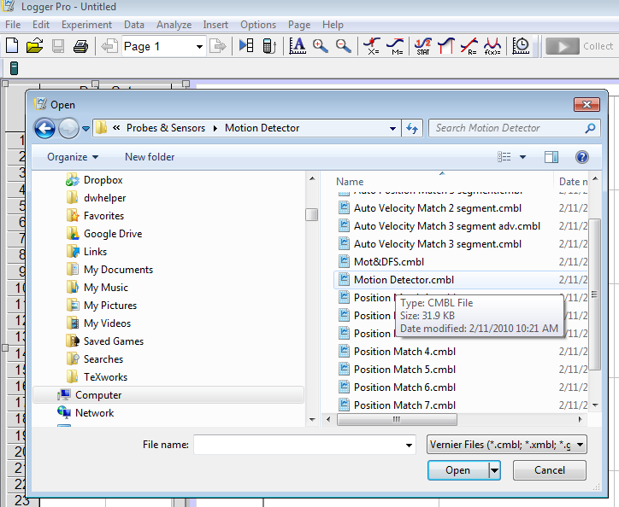 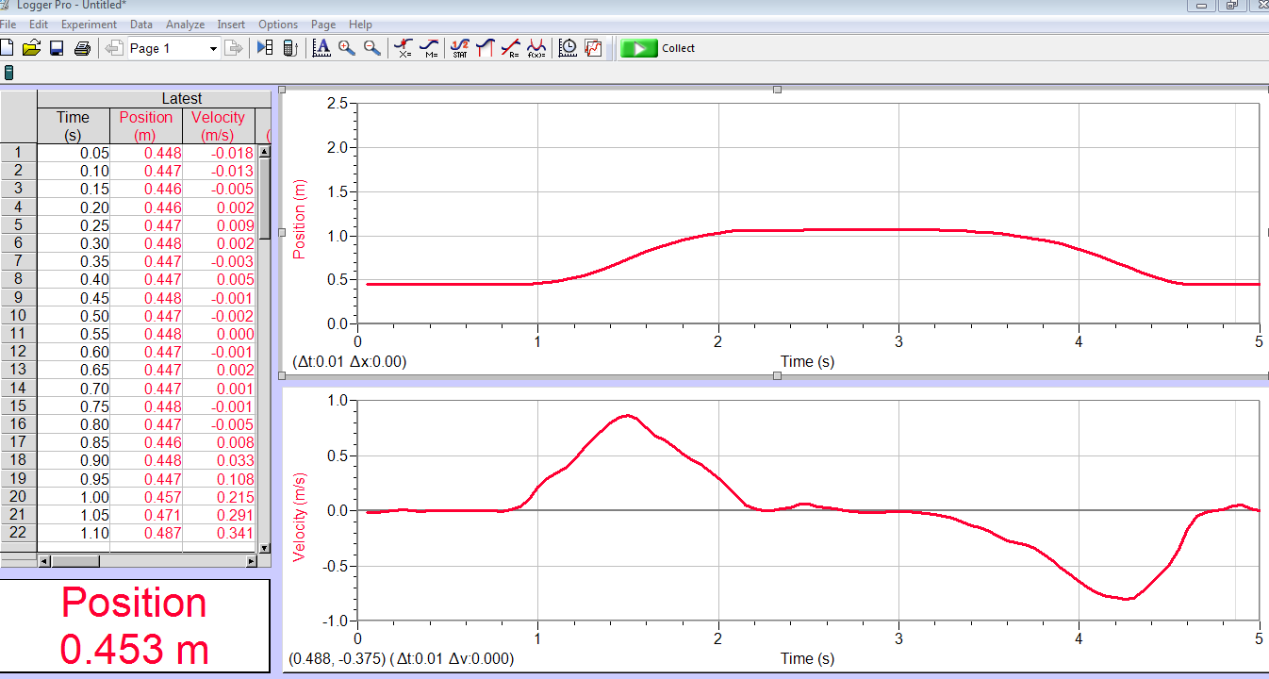

Please pay close attention to your instructor in how to set up an experiment for data collection. Your data collection screen should look like the one in the figure above (but without the data). There should be a graph showing position as a function of time and one showing velocity as a function of time.

Set the motion detector on the edge of your desk so that you may easily walk toward and away from the detector.

Do the following experiment. Stand about half a meter away from the detector. Hold a book or notebook at abdomen-level. Start the data collection and then move backward, away from the detector for a couple of meters. Stop. Wait a couple of seconds, then walk toward the detector. You should see something similar to the graph displayed above.

Please note the following features of both your graph, and the sample graph I have included above:

1) The velocity is zero in several places. These occur at different positions.

2) The position in this case is always positive, even though the velocity can be either positive or negative.

3) Notice that the speed (which is the absolute value of the velocity) must increase to some non-zero value when you start, and then decrease back to zero when you stop.

The position and velocity are related in the following way: If we call position, *x* and velocity, *v*, then the velocity is the time derivative of the position *v*=d*x*/dt. Please carefully inspect your figures to convince yourself that that is true. We will check it with Excel as described below.

If necessary, repeat the experiment several times, varying the manner in which you or your lab partner alternately approach and move away from the detector. When you have obtained a set of graphs that are “pleasing” to you, save that data, and **copy the time, position and velocity columns to an Excel spreadsheet** (as illustrated in the figure below). In Excel, label column D “dx/dt”. You are going to check that the velocity really is the derivative of the position.

Remember from Lab-0 that we modeled the derivative by taking differences: *x*/*t = (the change in x)/(change in time)*. Examine the formula in the figure below. It defines dx/dt for element D5 as D5=(B6-B4)/(A6-A4), which is more properly called *x*/*t* . I have also added an offset of 0.05 for purposes of display in order to be able to see both lines on the displayed graph. All three quantities are plotted below. Notice how exactly the measured velocity matches our calculation. You can see that *x*/*t* really does equal *v*! You do the same calculation in your Excel spreadsheet. Keep this spreadsheet open. We will be doing more with it in the next section. **Take a screen shot of your spreadsheet. Copy and paste it into the Word file.**

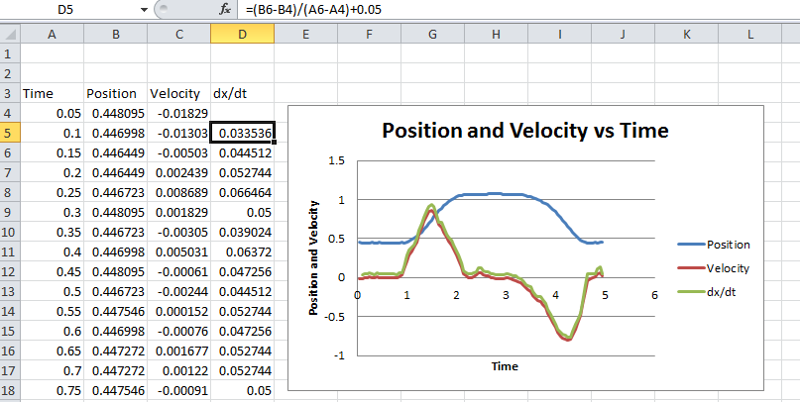Some thoughts for analysis: At any one point of the position versus time graph, the value of the velocity represents the slope of the position graph at that point. If the slope of the position graph is trending down, then the velocity must be decreasing and visa-versa, if the slope is trending up, the velocity must be increasing.

If the slope of the position graph is changing at all, then so must the velocity itself. This brings up the concept of acceleration. The acceleration is a measure of how fast the velocity is changing. **Inspect the velocity graph in the figure to the left, and answer the following questions by writing the your answers in your Word document:**

1) Which region on the velocity graph records the largest acceleration? (**Refer to the figure above, NOT to your graph**!)

(a) Between t=1 and t=1.5 seconds?

(b) At the top of the peak near t=1.5 seconds?

2) Which region has an acceleration that indicates the body is slowing down?

(a) Between t=1 and t=1.5 seconds?

(b) Between t=1.5 and t=2 seconds?

3) What can be said about the acceleration of the body near the “peaks” at about t = 1.5 seconds and t = 4.2 seconds? The velocity is at a maximum in both cases, but what about the rate of change of the velocity? Describe the acceleration near these points.

**Activity 2 – Measuring acceleration of a cart rolling up an incline**

Watching people move is fine, but tummies wiggle and jiggle and in general, there are parts of people in motion at times when they’d be better not doing so – at least as far as physics labs are concerned. So we’ll move on to something simpler to measure and quantify.

Clip the motion detector to the end of the aluminum track. Tilt the ramp slightly, so that the detector is on the lower part of the track. In this configuration, “positive” is “up” the track and “negative” is “down” the track. Make sure the distance setting on the motion detector is on the “cart” setting.

With the cart about 15 cm from the detector, give the cart a slight push up the track. Let it roll up the track and then roll back down. Catch it before it hits the motion detector. Practice this a few times to get a feel for how hard you need to push it to get it to go most of the way up the track and back. Once you have got the feel for it, push the data collection button and collect data. You should see a graph similar to that shown below in the figure on the left. If you don’t get something like that, try again! The motion sensors are tricky. Consult your instructor if you’re unable to get something similar to that.

The explanation and analysis of this graph can be rather involved. Please pay attention to the discussion presented by the lab instructor. His or her discussion will cover the use of the LoggerPro analysis software in addition to examining the physics! **Pay Attention**!

The significant forces acting on the cart after you have pushed it and before you catch it at the bottom are:

(1) Gravity, (2) A “normal” force of contact between the wheels and the track, and (3) friction between the wheels and the track. The carts are designed to minimize friction, and so compared to gravity, friction is small. We will ignore friction if possible. The normal force can only push out and away from the track, it cannot push the car up or down the track. Therefore, the only force able to change the motion of the cart in a significant way is gravity. (*Friction does not bring the cart to rest at the top of the track!*) Newton’s second law says that the acceleration of the cart must therefore be determined almost entirely by gravity.

Position, velocity and acceleration are related by the principles of differential calculus. We have already seen experimentally that *v*=d*x*/dt. We will now check that the acceleration is *a*=d*v*/dt. Refer to the graph below. Your data should look very similar.

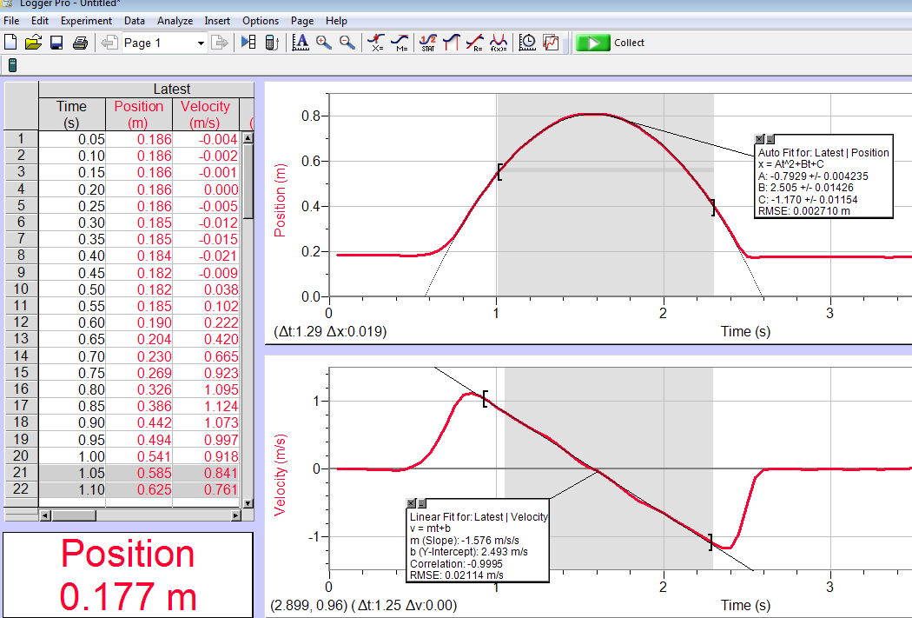 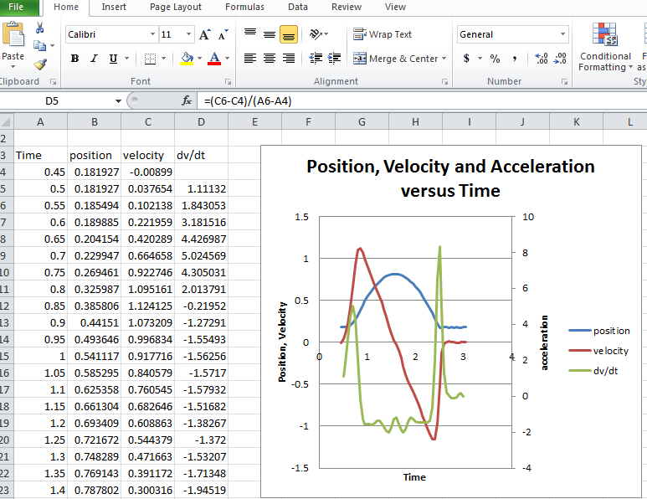

Look at the position graph first. It is obviously a parabola. Why? How is the motion of the cart similar to the tossing a ball in the air and catching it on the way down?

Using the left mouse button, highlight the parabolic region of your position curve. Then, using the LoggerPro “Analyze” tab, select “Curve fit...”, and from the menu of formulas pick the parabola option, “A*t^2+B*t+C”. Hit the “Try Fit” button and then “OK”. You will see a box on the graph that displays the values of A, B and C. If this were an experiment in which the acceleration of a ball was measured in free fall, then “A” should be equal to ½ of the gravitational acceleration constant, *g*, or A=½*g*, would equal 4.9 m/s2. But in this case, the slope of the ramp prevents the cart accelerating at that rate. Instead, a little analysis would show that under ideal circumstances, A*=*½*g sin(),*where ** is the angle at which the ramp is tilted. So the acceleration of the cart, a = *g sin(),* =2*A. (Keep this fit). Measure the angle of the ramp by directly measuring the “rise”/”hypotenuse” as demonstrated by your instructor. You will record this in your Word document shortly.

Consider the velocity curve for a moment. The first part of the curve in the figure shown above between 0.5 and 0.8 seconds is that time in which the velocity is increasing because the cart is being pushed. (Your graphs, of course, will be different) Later, between about 2.4 and 2.6 seconds, the cart is being caught at the bottom. The time between about 0.8 and 2.2 seconds is the time during which the cart is moving primarily under the influence of gravity, (with just a little friction that we will ignore). Use the analyze function again, and fit the part of the line in ***your*** velocity data that corresponds to the time interval the cart was rolling freely. Pick the “Linear Fit” option, and hit “OK” to display the value of the fit on the graph. The slope of the velocity curve should be a direct measure of the acceleration. It should be equal to the acceleration you measured from the parabola. So you now have two independent measurements of the acceleration, one from the position measurement and one from the velocity measurement. Are they the same?

Record the following data in the Word document.

(1) Copy and paste your graphs of position versus time and velocity versus time into the Word document.

(2) Record your predicted acceleration (*g* sin**). ______________(m/s2)

(3) Record the measured acceleration from the position graph fit (2*A) ______________(m/s2)

(3) Record the measured acceleration from the slope of the velocity curve: _______________(m/s2)

Find the percent errors for each of these measurements: %error = (Predicted value – Measured value)/Predicted value * 100%

(4) Percent Error for acceleration measured from position graph: ___________

(5) Percent Error for acceleration measured from velocity graph: ___________

Now we’ll check the calculus of it! Does *a = dv/dt*? Copy and paste the time, position and velocity data from the LoggerPro spreadsheet into a new set of columns in your Excel worksheet. Define Column D to be dv/dt and just as you did in the previous case, make column D the numerical derivative, in this case, of the velocity in column C, such that, for instance, D5 = (C6-C4)/(A6-A4).

Make a graph of the three quantities of interest and produce a plot similar to the one shown above. Right click on the dv/dt graph line and choose “Format data series”. Then choose to display it against the “secondary vertical axis”, so that position and velocity are measured against the scale on the left and acceleration is measured against the scale on the right. (Don’t get mad, when the instructor says “see lab write up for details”!...) See the figure above for reference. **When you have completed your Excel plots, copy your graphs and paste them in the Word document.**

Here’s what you should notice, and here’s what you should learn: From the time the cart left your hand, until the time you caught it, the only net force acting on it was the component of gravity pulling it back along the track. Gravity can’t turn off. That means it must have been continuously accelerating down the track the whole time, even when it was going up and even when it was “stopped” at the top. The measured acceleration, therefore, from the time you let the cart go until you caught it again, should be constant – so inspect your graph. Aside from some wiggles due to friction, how would you describe the acceleration?

**In your Word Document write a brief summary of the meaning of the acceleration graph**. In forming your answer, consider the time from when the cart left your hand to the time that you caught it again. Describe what the acceleration is doing. Is it mostly constant? Did it change direction or sign? What is its value? What forces are at play? Does it agree with the measurements you made with Logger Pro? Please answer these questions in the Word document.

**Discussion**: Most people are surprised to find that the acceleration of the cart stays constant. When asked directly, “what is the acceleration of the cart at the point that it turns around?”, most people will answer “Zero!”. But you have now seen that this is wrong. Completely and totally wrong. The point at which the cart reaches the top of the track is the point at which the velocity goes instantaneously through zero, going from positive to negative values. So, yes, the velocity is zero there. But not the acceleration! It CAN’T be! If it had no acceleration at the top, and had no velocity at the top, either, **then it could not move from that position**! Instead, the velocity is changing at a constant rate in the downward direction, regardless of how the cart is initially moving or what its instantaneous velocity is. What it means to have a constant acceleration is that the velocity **must change** the **same amount** in the **same time** in the **same direction**, all the time.

Notice the big spikes on either end of the acceleration graph. These correspond to the accelerations caused by your hand. The first spike is a reflection of the large positive force and acceleration you temporarily had to impose to give the cart some initial upward speed. The second spike corresponds to the large (upward) force you had to exert to stop the cart. Otherwise, the only force acting is gravity, and gravity can only pull down, so that the acceleration you measure is (aside from friction-induced wiggles) constant in time, and negative. If you truly understand that, and accept it, then you are officially a Newtonian Thinker. Congratulations!

Print out your copy of your Word document. Make sure both your name and your lab partner’s name is on it!

If you have time, please do activity three found on the next page. Draw the required graphs from activity 3on your printed document for submission.

**Activity 3 – Mimicking an arbitrary motion**

OK, one last challenge. Below is a plot of *velocity* vs. time. With your lab partner, discuss how you would produce this plot using your own body. When you think you have it figured out, run the motion sensor and do it. Trace your attempt at *v*(*t*) over the plot below, and also include a plot of the position vs. time for this motion. Start your motion at 0.5 m away from the motion sensor. Will you end up further away than 0.5 m when you’re done? Explain.

*t*

*t*

*x*(*t*)

*v*(*t*)

Print out a copy of your Word document. Make sure your name is on it.